# Micro PET Test 1

Most computers have a hard disk. What is this referred to as?

A. Primary Storage

B. Secondary Storage

C. RAM

D. ROM

ANSWER: B

The microbit has approximately 30kb of storage available to store your program. How many letters, symbols or numbers can it store?

A. 300

B. 3000

C. 30000

D. 300000

ANSWER: C

If you flash your microbit, what will happen to your data?

A. It will be saved

B. It will be deleted

C. It will be saved and then updated

D. Nothing

ANSWER: B

Which of the following file types can be used to store music?

A. .ppt

B. .mov

C. .mp3

D. .doc

ANSWER: C

In the code below, what does the ‘w’ mean?

with open(**'hello.txt'**, 'w') as newFile:

newFile.write("**Hello my name is**")

A. The hello.txt file will temporarily be stored as w

B. The file is opened in write format

C. The file is being loaded from the w drive on the computer

D. The letter w will be added to the text file

ANSWER: B

Which command can be used to show the file directory on the microbit?

A. os.listdir()

B. os.show()

C. os.showfiles()

D. os.showdir()

ANSWER: A

What is the purpose of the machine module?

A. To be able to control machines which are connected to the microbit

B. To allow other machines to communicate with the microbit

C. To allow access to hardware such as the CPU, timers and buses on the microbit

D. To be able to access the microbit via a PC

ANSWER: C

The amount of work being carried out by the CPU is measured by the frequency. Which unit of measurement is used to display the frequency?

A. MB

B. GB

C. .dB

D. .Hz

ANSWER: D

Which line of code below will perform the same function as pressing the reset button?

A. microbit.reset()

B. machine.reset()

C. kernel.reset()

D. reset()

ANSWER: B

Which of the statements below correctly describes the LEDs on the microbit?

A. The LEDs can only produce light

B. The LEDs can both produce and measure light

C. The LEDs can only measure light

D. The LEDs are a type of capacitor

ANSWER: B

Python is an object oriented language which uses classes. What is a class similar to?

A. A fruit bowl which contains lots of different, but related objects

B. A single line programming statement

C. A type of iteration

D. A bucket which holds lots of unrelated objects

ANSWER: A

When using the microbit to send and receive data wirelessly all of the communicating microbits should be set to use the same channel to avoid interference. Which command can be used to set the channel?

A. microbit.config(channel=10)

B. wifi.config(channel=10)

C. bluetooth.config(channel=10)

D. radio.config(channel=10)

ANSWER: D

What does the code snippet below mean?

if msg != None:

A. if no msg:

B. if msg is none:

C. if msg is not equal to none:

D. if msg is a warning:

ANSWER: C

You wish to set your microbit to receive data from one of your friends microbits via radio. What would happen if you don’t set the channel?

A. You won’t receive any data via radio

B. You will receive data only from the nearest microbits

C. You will receive data from all microbits that are within range

D. It will crash your microbit

ANSWER: C

The pins on the microbit can be used to control both the microbit and external devices. What is the equivalent of adding a crocodile clip to PIN 5 and joining it to the GND pin?

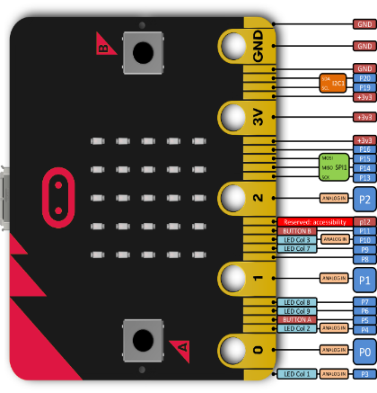

A. Pressing reset

B. Flashing the microbit

C. Pressing button A

D. Pressing button B

ANSWER: C

What is the name of the device pictured below?

[This Photo](https://learn.digilentinc.com/Documents/195) by Unknown Author is licensed under [CC BY-NC](https://creativecommons.org/licenses/by-nc/3.0/)

A. Sensor

B. Microcontroller

C. Capacitor

D. Servo

ANSWER: D

In Python, why do we sometimes add a # at the start of a line of code?

A. To tell the computer that this is the most important line of code

B. To tell the computer to ignore the line of code when running the program

C. To tell the computer to create a new variable

D. To tell the computer to only run this line of code

ANSWER: B

Which command below would create a new function called actions?

A. function actions():

B. subprogram actions():

C. def actions():

D. actions()

ANSWER: C

Which line in the program below contains an example of sequence?

1. while True:
2. while running == True:

needs = random.randint(1, 4) **#change after testing**

sleep(1000)

03. if needs == 1:

cuddles()

04. running = False

sleep(1000)

A. 01

B. 02

C. 03

D. 04

ANSWER: D

A function has been defined in Python called cuddles. Which line of code can be used to run the function?

A. run cuddles

B. run cuddles()

C. cuddles()

D. execute cuddles()

ANSWER: C